**Reference guide: Pandas tools for structuring a dataset**

## Pandas structuring reference guide

As you’ve learned, there are far too many Python functions to memorize all of them. That’s why, as every data professional will tell you, you’ll be using reference sheets and coding libraries nearly every day in your data analysis work.

The following reference guide will help you identify the most common Pandas tools used for structuring data. Note that this is just for reference. For detailed information on how each method works, including explanations of every parameter and examples, refer to the linked documentation.

## Combine data

Note that for many situations that require combining data, you can use a number of different functions, methods, or approaches. Usually you’re not limited to a single “correct” function. So if these functions and methods seem very similar, don’t worry! It’s because they are! The best way to learn them, determine what works best for you, and understand them is to use them!

[**df.merge()**](https://pandas.pydata.org/docs/reference/api/pandas.DataFrame.merge.html)

* A method available to the DataFrame class.
* Use df.merge() to take columns or indices from other dataframes and combine them with the one to which you’re applying the method.
* Example:

df1.merge(df2, how=‘inner’, on=[‘month’,’year’])

[**pd.concat()**](https://pandas.pydata.org/docs/reference/api/pandas.concat.html)

* A pandas function to combine series and/or dataframes
* Use pd.concat() to join columns, rows, or dataframes along a particular axis
* Example:

df3 = pd.concat([df1.drop(['column_1','column_2'], axis=1), df2])

[**df.join()**](https://pandas.pydata.org/docs/reference/api/pandas.DataFrame.join.html)

* A method available to the DataFrame class.
* Use df.join() to combine columns with another dataframe either on an index or on a key column. Efficiently join multiple DataFrame objects by index at once by passing a list.
* Example:

df1.set_index('key').join(df2.set_index('key'))

Visual representation of a combination:



## Extract or select data

**df[[columns]]**

* Use **df[[columns]]** to extract/select columns from a dataframe.
* Example:

df[['animal', 'legs']]

[**df.select_dtypes**](https://pandas.pydata.org/docs/reference/api/pandas.DataFrame.select_dtypes.html)**()**

* A method available to the DataFrame class.
* Use df.select_dtypes() to return a subset of the dataframe’s columns based on the column dtypes (e.g., float64, int64, bool, object, etc.).
* Example:

df2 = df.select_dtypes(include=['int64'])

Visual representation of extraction:



## Filter data

Recall from Course 2 that Boolean masks are used to filter dataframes.

**df[condition]**

* Use df[condition] to create a Boolean mask, then apply the mask to the dataframe to filter according to selected condition.
* Example:

df[df['class']=='Aves']

Visual representation of filtering:

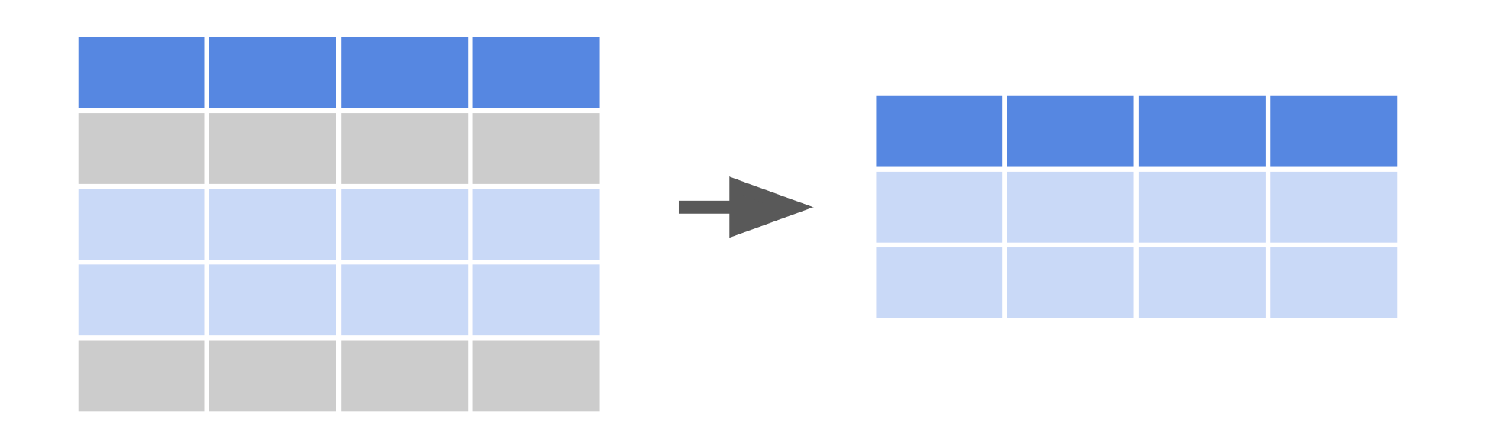

## Sort data

[**df.sort_values()**](https://pandas.pydata.org/docs/reference/api/pandas.DataFrame.sort_values.html)

* A method available to the DataFrame class.
* Use df.sort_values() to sort data according to selected parameters.
* Example:

df.sort_values(by=['legs'], ascending=False)

Visual representation of sorting:

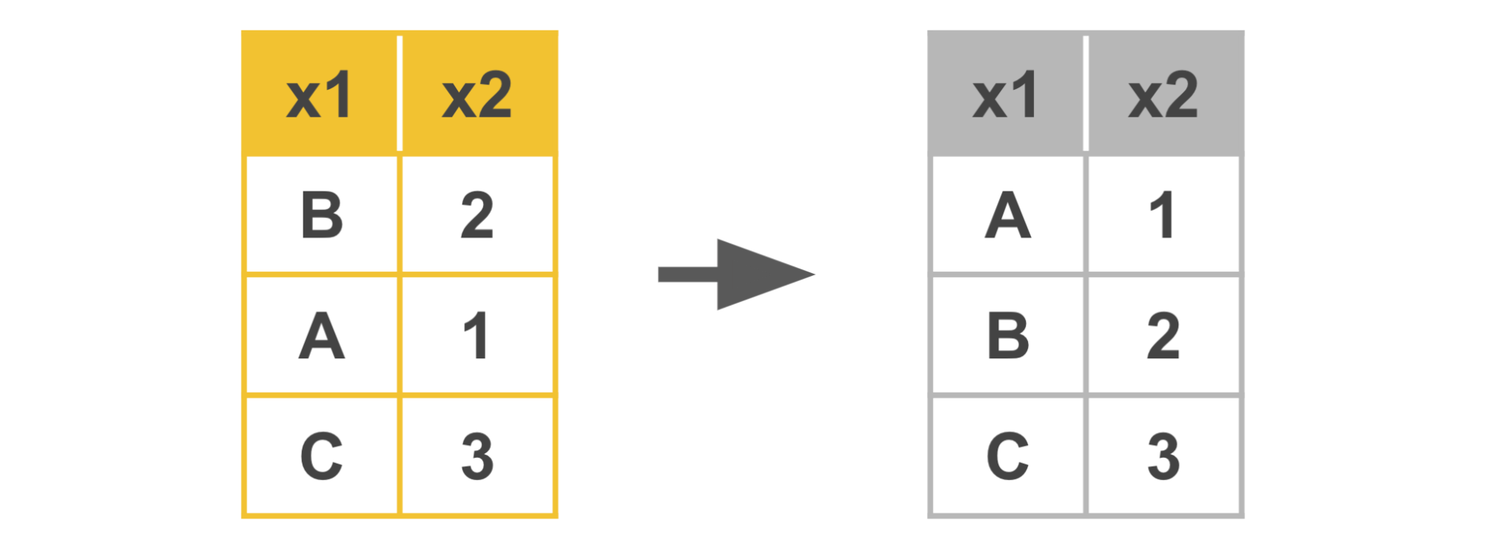

## Slice data

[**df.iloc[]**](https://pandas.pydata.org/docs/reference/api/pandas.DataFrame.iloc.html)

* Use df.iloc[] to slice a dataframe based on an integer index location.
* Examples:

df.iloc[5:10, 2:] → selects only rows 5 through 9, at columns 2+  
df.iloc[5:10] → selects only rows 5 through 9, all columns  
df.iloc[1, 2] → selects value at row 1, column 2  
df.iloc[[0, 2], [2, 4] → selects only rows 0 and 2, at columns 2 and 4

[**df.loc[]**](https://pandas.pydata.org/docs/reference/api/pandas.DataFrame.loc.html)

* Use df.loc[] to slice a dataframe based on a label or Boolean array.
* Example:

df.loc[:, ['color', 'class']]

## 

## Key takeaways

The tools in this reference guide are foundational to structuring data, including filtering, sorting, merging, and slicing. You will find yourself using them throughout your career as a data professional.

## Resources for more information

Refer to these links for more details on Python functions and their various parameters.

* [Pandas documentation to describe parameters in Python functions](https://pandas.pydata.org/docs/index.html)
* [W3schools provides explanations for Python functions in an easy-to-understand way](https://www.w3schools.com/)